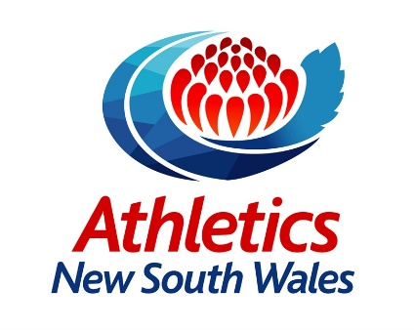
Active Kids Vouchers

Instructions:
To apply for the voucher:
https://www.service.nsw.gov.au/transaction/apply-active-kids-voucher
Please note, there are TWO $100 vouchers available this year. On Jan 1st and July 1st they are made available to apply for and download.
To claim the voucher please follow these steps:
- Register with Athletics NSW for a Concession Membership
- Fill out the form below and email to memberships@nswathletics.org.au
- Await confirmation from Athletics NSW that your voucher has been processed and you will be reimbursed your Active Kids Voucher Rebate.
Please note, Creative Kids Vouchers cannot be used towards ANSW Membership.

Full Name:
Date of Birth:
Voucher Number:
Email Address:
Mobile:
ANSW Club:
BSB:
Bank Account Number:

If you have any issues, please email memberships@nswathletics.org.au

